Operations Management

Don Groh Ph. D.

May be defined as the design, operation, and improvement of the **production systems** that create the firm’s primary products or services.

A production system uses **operations resources** to **transform** inputs into some desired outputs.

**Why Study Operations Management**

* Increase productivity and standard of living.
* Systematic approach to design, operation, and improvement of production systems and their processes.
* OM is one of the three major functions (marketing, finance, and operations) of any organization.
* OM is where large costs are generated and controlled.
* Career Opportunities. (E.g. Chief Operating Officer, Plant Manager, Quality Control Manager, Procurement Manager, Supply Chain Manager, Project Manager, Facilities Manager, etc.)
* Cross-Functional Applications

**Production system**

A production system uses **operations resources** to **transform** inputs into some desired outputs.

**Operations Resources**

Consist of the five P’s of operations mgt.

**People**

**Plants**

**Parts**

**Processes**

**Plans**

**Transformations**

**Physical** as in manufacturing

**Location** as in transportation

**Exchange** as in retailing

**Storage** as in warehousing

**Physiological** as in health care

**Informational** as in telecommunications

**Ten Critical OM Decision Areas**

Service and product design

Quality management  
Process design and capacity management

Facility location selection

Facility layout design

Human resources and job design

Supply and information chain management

Inventory management

Scheduling

Maintenance

**Differences between goods and services**

A **good** is an object, device, or thing.

A **service** is a deed, a performance, an effort. Service is the application of competencies (knowledge and skills) for the benefit of others. Services can be considered as acting on people’s ***minds***, (e.g. education, entertainment, religion), ***bodies*** (e.g., transportation, lodging, health care), ***belongings*** (e.g., auto repair, dry cleaning, banking), and ***information*** (e.g., tax preparation, insurance, legal defense). In some service industries like the hotel industry the service amounts to the sharing if their resources among customers by allocating the use of them. No change of ownership. Services may complement goods; at other times, goods may complement services.

G**oods and services and the OM Decisions**

|  |  |  |
| --- | --- | --- |
| **Operations Decisions** | **Goods** | **Services** |
| Services and Product Design | Determine and then translate customer requirements into design requirements.  Design using the minimum number of parts. | Service delivery system (structure) should be appropriate to accommodate volume of output and degree of uncertainty (customer contact - front stage vs. backstage operations). |
| Quality Management | Conformance to Specifications.  Specifications quantified by designer.  Target and range. | Customer perceptions of service received relative to customer expectations. Service quality is judged by both the process of service delivery and the outcome of the service. |

G**oods and services and the OM Decisions**

|  |  |  |
| --- | --- | --- |
| **Operations Decisions** | **Goods** | **Services** |
| Process design and capacity management. | Process used is a function of degree of uncertainty and volume of output. Customer is not involved in the production process. Uniform Plant Loading. Level Schedule. Uniform production Rate. | Process used is a function of degree of uncertainty resulting from degree of customer contact. The customer is often involved in production process. (inseparability). At any given time, capacity must match demand because services cannot be inventoried. |
| Facility Location Selection | Objective is to minimize cost. Locate near raw materials and labor to reduce cost. | Objective is to maximize revenue. Locate near customer to increase customer contact. |

G**oods and services and the OM Decisions**

|  |  |  |
| --- | --- | --- |
| **Operations Decisions** | **Goods** | **Services** |
| Facility Layout and Design | Objective is to minimize material handling cost (CRAFT), common customers, supervision, etc. | Objective is to maximize profit by maximizing product exposure & minimizing material handling cost. Service delivery (behavioral considerations) are important (Servicescapes). |
| Human resources and job design | Requires Technological Skills. Quantifiable work standards possible. | Requires Human Relation Skills. Quantifiable work standards harder to set. Knowledge Based. |

G**oods and services and the OM Decisions**

|  |  |  |
| --- | --- | --- |
| **Operations Decisions** | **Goods** | **Services** |
| Supply Chain Management and Design | Supply Chain Design is a function of supply and demand uncertainty. | The customer supplier duality creates a network of relationships rather than a chain as found in manufacturing. |
| Inventory Management | Goods can be inventoried. How much should we order and when? | Services cannot be inventoried (intangible). Requires capacity management or demand management. |
| Scheduling | Level schedules are possible and desirable. | Supply must match demand through time. |
| Maintenance | Preventive | Repair |

**Significant Events in Operations Management**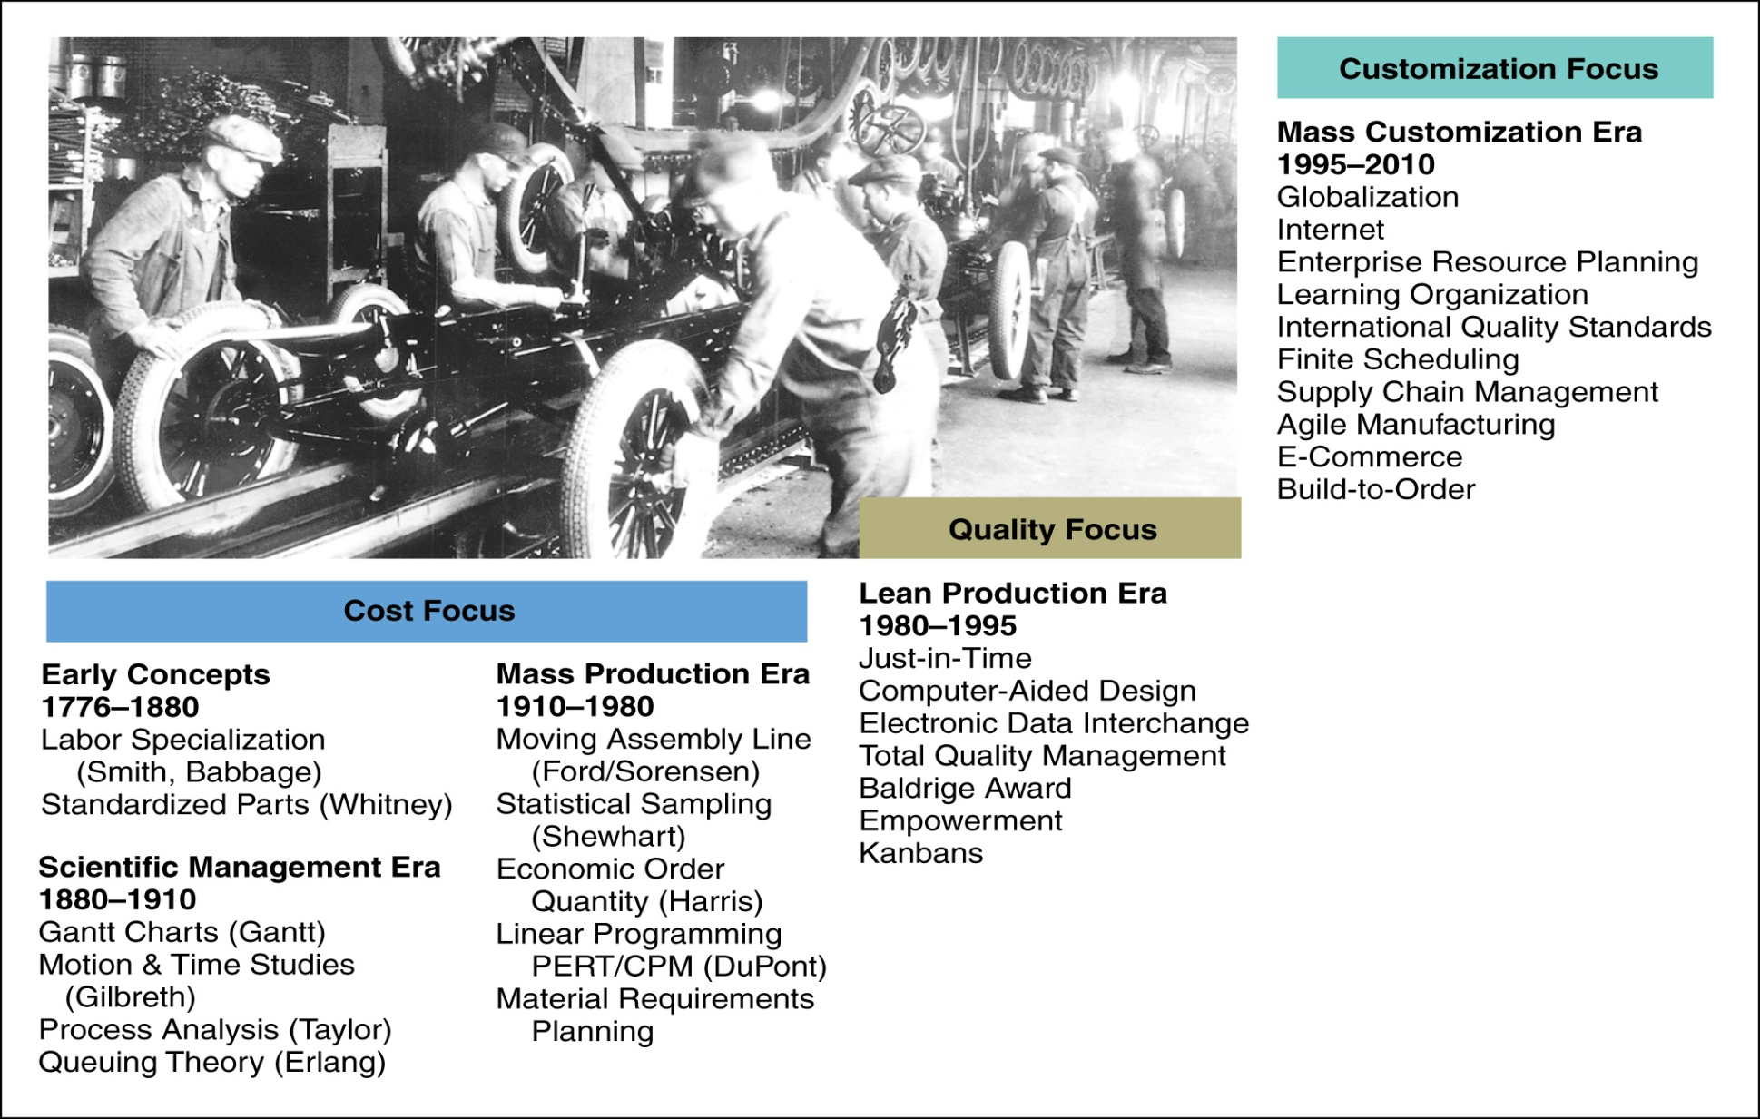

Source: Heizer and Render, *Operations Management Flexible Version,* 8th Edition, Pearson, Prentice Hall, 2007**Significant Events in Operations Management**

#### Cost Focus 1776-1980

* **Early Concepts: 1776-1880**
  + Labor Specialization-Adam Smith (The Wealth of Nations)
  + Interchangeability of Parts-Eli Whitney
* **Scientific Management Era: 1880-1910**
  + Gantt Charts-Gantt
  + Reducing Motion - Frank and Lillian Gilbreth
  + Reducing Process Time & Separate Planning from Execution - Fredrick Taylor (Mechanical Engineer and Father of Scientific Management)
  + Queuing (Waiting Line) Theory - Erlang

**Significant Events in Operations Management (Cont.)**

#### Cost Focus 1776-1980 (Continued)

* **Mass Production Era: 1910-1980**
  + Moving Assembly Line (1913)-Henry Ford
  + Hawthorne Studies (1930s)-Elton Mayo (Father of Human Relations)
  + Statistical Sampling (1930s) -Shewhart, Dodge, & Romig
  + Economic Order Quantity(EOQ) -Harris
  + Linear Programming (1940s)-Dantzig
  + Multidisciplinary Teams (1940s)-U.S. Military
  + Operations Research (OR) (1950&60)
  + Material Requirements Planning (MRP)

**Significant Events in Operations Management (Cont.)**

#### Quality Focus 1980-1995

* **Lean Production Era: 1980-1995**
  + Just-in-Time Production (JIT) (1970s) -Toyota’s Ohno
  + Computer Aided Design (CAD)
  + Electronic Data Interchange (EDI)
  + Manufacturing Strategy Paradigm (1980s)-Kim Clark
  + Service Quality (1970&80s)-Zeithaml, Berry, Parasuraman
  + Total Quality Management (TQM), Baldrige Awards, ISO Certification, Empowerment, and Kanbans (1980&90s) - Edward Deming, Joseph Juran, & Philip Crosby
  + Business Process Reengineering (1990s)-Michael Hammer

**Significant Events in Operations Management (Cont.)**

#### Customization Focus

* **Mass Customization Era (1995-2010)**
  + Globalization
  + Internet
  + Enterprise Resource Planning
  + Learning Organization
  + Supply Chain Management-SAP & Oracle
  + e-Commerce-Amazon, eBay, AOL, Yahoo
  + Make to Order

**Operations Management Emergence as a Field**

In the late 1950s and early 1960s scholars began dealing specifically with OM as opposed to industrial engineering or operations research.

**Strategy and Positioning (Differentiation or Uniqueness)**

1. A strategy is a plan for the creation of a unique and valuable position,by using a unique set of activities. A position may be based on a number of dimensions to include - focus or not focus on a particular market segment or customer need: overall cost leadership: or differentiation through product leadership (offering a unique product or service), customer intimacy, operational excellence (focus on a particular operating priority (speed, cost, quality, or flexibility), branding, technology, information technology, distribution channel or network design, and facility design. These positions are then translated into a unique set of activities that go into creating, producing, selling, and delivering a product or service and are the basic units of achieving competitive advantage.

**Strategy and Positioning (Differentiation or Uniqueness)**

Strategic positioning attempts to achieve sustainable competitive advantage by preserving what is different about the company. It means performing different activities from rivals, or performing similar activities in different ways.

2. A strategy may require trade-offs. Some competitive activities are incompatible. Gains in one area can be achieved only at the expense of another. E.g. You cannot be a low cost provider and have many services.

3. A strategy involves creating a “fit” amongst its activities, facility design, image, and position. When activities, facility design, image, and position reinforce each other competitors can’t easily imitate them.

**Competitive Advantage**

**Competitive Advantage** is about being different. The essence of strategy is in business activities. It means deliberately choosing a different set of activities to deliver a unique mix of value. Choosing to perform activities differently or to perform different activities than rivals

E.g. Southwest Airlines: Competitive Strategy:

Low Cost, High Convenience

Supporting Activities:

No Meals, No Seat Assignments, No Baggage Transfers, Routes about same the distance, same type aircraft, No reservations,

**Strategic Planning**

Many corporations have a “divisional” structure (verses a functional or matrix structure) that consist of three organizational levels:

* Corporate level
* Business level
* Product level

Each level develops its own strategies and plans:

* Corporate strategic plan
* Business strategic plan
* Marketing plan

# **Corporate Strategic Plan**

The **Corporate Strategic Plan** should describe how your firm intends to create and sustain value for its stakeholders and be environmentally, economically, and socially sustainable (triple bottom line). It should integrate the finance, marketing and operations functions.

A **corporate strategic plan** may consist of:

* A Corporate Mission Statement: which should; state the purpose for the existence of the organization; provide a vision statement and direction for the next twenty years; be motivating; and identify core competencies, service concept, technologies, focus areas, geographic markets, operating priorities, vertical scope and delivery systems.

**Corporate Strategic Plan**

* A strategic service vision addresses questions about the target market, service concept, operating strategy, and delivery systems. The competitive environment of services presents challenges such as low entry barriers, product substitutions, and limited opportunities for economics of scale, demand fluctuations, disadvantage of size in dealing with buyers and suppliers, customer loyalty, and exit barriers (not profit motivated) that must be overcome.
* Identified Strategic Business Units (SBUs): Strategic Business Units may be defined by the organizational output: product, region, project, customer or need that will be met.

**Corporate Strategic Plan**

* An analysis of the current portfolio of businesses using tools such as Boston Consulting Groups Growth-Share matrix to classify SBUs (Stars, Cash Cows, Question Marks and Dogs) in order to determine which SBU’s to build, maintain, harvest, or divest.

**Corporate Strategic Plan**

The strategic analysis may also involve developing future environmental scenarios, determining core competencies required to survive in each of the scenarios, and then developing appropriate initiatives to attain those required core competencies. The scenarios are developed from environmental variables that impact the firm like customer preferences, new technologies, or changes in demographics.

* The identification of new businesses/industries to enter or core competencies/key success factors to develop.
* Goal and Objective Statements with supporting actions.

**The Kaplan and Norton Strategic Map**

Kaplan and Norton developed a generic strategy map that facilitates defining the customer value proposition and increases awareness that internal processes, competencies, and technologies must be linked to that value proposition. It assists in the integration of the finance, marketing, and operations functions.

The purpose is to foster a cause-and-effect mentality that encourages more innovative approached to strategy implementation.

**Kaplan and Norton’s Generic Strategic Map**

**Financial Perspective** (backward in time) There are two strategies for driving financial performance: growth and productivity

**Customer Perspective** (outward in space) is the heart of the strategy and defines how growth will be achieved. **A company may differentiate itself three ways: product leadership, customer intimacy, and operational excellence.**

**Internal Perspective** (inward in space) defines the business processes (innovation, customer relations, operational, and environmental) and the specific activities the organization must master to support the customer value proposition.

**Learning and Growth Perspective** (forward in time) defines the intangible assets (strategic competencies and technologies, and climate for action) needed to enable activities and customer relationships to be conducted at high levels of performance.

**Kaplan and Norton’s Generic Strategic Map**

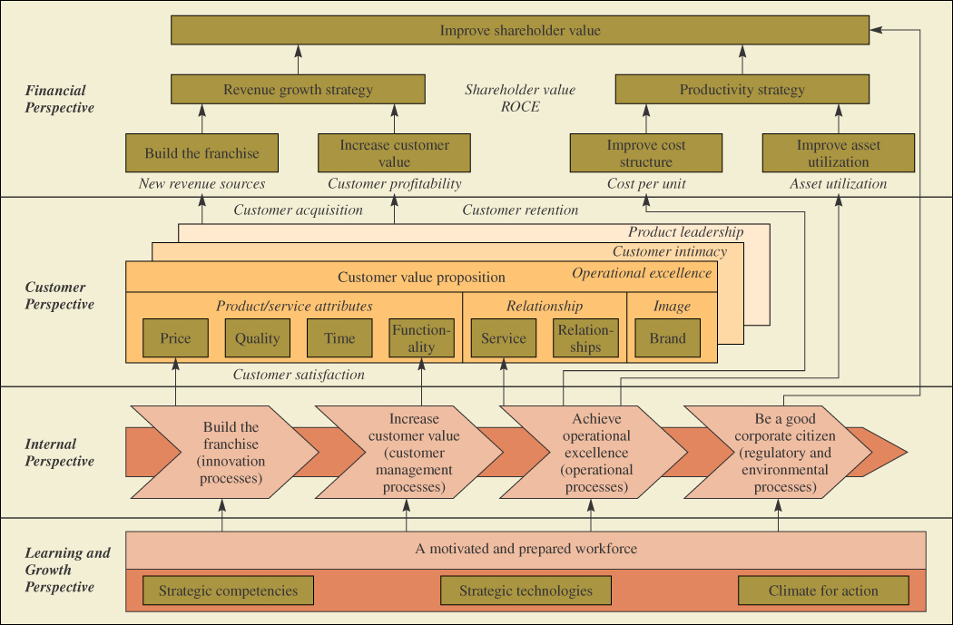

# **Business Strategic Plan**

A **business strategic plan** may consist of:

* + A Business’s Mission Statement: which should state; the purpose for existence; the organizational output (product, region, project, customer or need that will be met); the competitive strategy (product leadership, customer intimacy, and operational excellence (or other)); technology; geographic markets; operations priorities; vertical scope and service delivery system.

**Business Strategic Plan**

* An analysis of the business using such tools as the Internal and External Environment Analysis (SWOT analysis) - The external analysis consists of identifying the market **opportunities** and environmental **threats**. By assessing the major threats and opportunities it is possible to characterize a market’s overall attractiveness. The internal analysis consists of identifying the company’s marketing, financial, manufacturing, and organizational **strengths** and **weaknesses**. The objective is to match up strengths with opportunities and weaknesses with threats.
* Goal and Objective Statements with supporting actions.

# **Business Strategic Plan**

Developing Business Goals, Strategies and Plans. The possible strategies that a SBU may adopt to obtain a competitive advantage are:

* + **First Focus (or not Focus)**, where the SBU uses a differentiation and/or an overall cost leadership strategy to a particular market segments rather than the entire market.
  + **Then Overall Cost Leadership**, where the SBU focuses on lowering its production and distribution cost in order to win market share.
  + **Or Differentiation**, where the SBU focuses on establishing a unique position and customer loyality.

## **Marketing Plan**

Activities performed in developing a **marketing plan** involve making decision about the:

* Product
* Price
* Promotion
* Place

**Operations Strategy**

**Operations strategy** is concerned with setting broad policies and plans to best support its long term competitive strategy.

It involves decisions that relate to the design of a process and the infrastructure needed to support the process.

**Operating Priorities / Competitive Dimensions** that organizations may employ to provide products and services that satisfy their customer’s value construct are:

**Quality**

**Flexibility**

**Speed**

**Cost**

**The Customer “Value” Proposition (Construct)**

**Flexibility + Speed + Quality**

**Value = Cost or**

**Results Produced for the Customer**

**Cost (to include acquisition costs)**

Customers want a defect free product or service (**quality**), tailored to their needs (**flexibility**), and delivered when they need it (**speed**), at the lowest possible price (**cost)**.

The corporate, business, product, and functional strategies and plans, internal processes, competencies and technologies should be aligned with and support the customer value proposition.

**Operations Focus, Trade-offs and Supporting Activities**

Central to the concept of operations strategy is the notion of **operations focus** and **tradeoffs**.

Trade-offs occur when activities are incompatible, so that more of one thing necessitates less of another. Speed vs. Quality

Speed vs. Flexibility. Quality vs. Cost. Must prioritize and focus.

**Strategic Positioning**

First, Focus or not Focus

Then, Overall Cost Leadership

Or Differentiation

Product Leadership, Customer Intimacy, Operational Excellence (Speed, Quality, Flexibility, Cost), Branding, Technology,

Information Technology, Distribution Channel or Network Design, and Facility Design.

**Competitive Dimensions for Services**

Customer selection of a service is often based on the following dimensions:

* + Availability (Accessibility)
  + Convenience (Location)
  + Dependability (Reliability)
  + Personalization (Flexibility)
  + Price (Cost) (In services price is often seen as a surrogate for quality)
  + Quality
  + Reputation
  + Safety
  + Speed

**Goal and Objective Statements**

All of these different types of plans (corporate, business, product, and functional) should contain goal and objective statements.

A goal statement is normally a higher order statement than an objective statement. Goal and objective statements should specify a unit of measurement, a target value for that unit of measurement, and a date of attainment of that target value.

Goal and objective statements should be SMART: Specific, Measurable, Achievable, Relevant, and Timely.

Example: Reduce the average time to perform a Policy Compliance Review on Decision Documents from 45 days to 30 days by December 2013.

**Strategic Uses of Information in Services to Achieve a Competitive Advantage**

**Creation of Barriers to Entry:** Many service markets have low barriers to entry. Information can create barriers through: a reservation system (e.g. American Airline’s SABRE system); a frequent flyer or similar program to create customer loyalty; and systems to create customer relationships and switching costs (medical ordering equipment, automatic bank deposits).

**Revenue Generation:** Information technology may be used to increase revenue through: a yield management system to make pricing and allocation decisions on unsold assets (airline seats and hotel rooms); the use of Point-of-Sale, location, and product information to increase stakeholder situational awareness and efficiency; and an expert system to assist stakeholders perform diagnostic test, analysis, and decisions.

**Strategic uses of Information in Services to Achieve a Competitive Advantage**

**Database Asset:** Databasesare assets of strategic importance. The data may be sold to other companies, mined for information (buying habits), and used to target customers with precision (micromarketing).

**Productivity Enhancement:** Multisite service operations can be managed better by using input and output data coupled with Data Envelopment Analysis (Linear programming) to identify which sites have a higher productivity, identifying what makes them more productive, and then sharing that information with the less productive outlets.

**Wickham Skinner’s Plant-Within-a-Plant**

Each location in a plant is operated according to its own strategy.

###### **Terry Hill’s Order Qualifiers, Winners and Losers**

**Order Qualifiers** are the basic criteria that permit a firm’s products to be considered as candidates for purchase by customers. (e.g. for an airline, certain level of safety)

**Order Winners** are the criteria that differentiate the products and services of one firm to another.

**Order Losers** are criteria that if not performed at the expected level will result in a dissatisfied and lost customer.

Often minimum quality, speed, and flexibility standards are set and become the order qualifiers and cost is the order winner.

**Productivity**

Productivity measures are “relative” measures. That is, productivity values have no meaning until those values are compared to productivity values of other similar organizations or the productivity values of the same organization at different points in time.

**Productivity (Continued)**



Partial Productivity Measures:

Output / Single Input

Multifactor Productivity Measures:

Output / Multiple Inputs

Total Productivity Measures:

Output / Total Inputs

Remember that you can multiply or divide variables which have different units but you cannot add them.

E.g. (1 ft.) (1 lbf.) = 1 ft. lbf. of energy

Productivity as it relates to some particular output of interest are sometime useful.

Business Productivity Measure

Restaurant Meals per Labor Hour

Retail Store Sales per Square Foot

Chicken Farm Lb. of Meat per Lb. of Feed

Utility Plant Kilowatts Per Ton of Coal

Paper Mill Tons of Paper per Cord of Wood

Significant Digits

Measurements are uncertain. When numbers are based on measurement, then only the numbers that have meaning (are significant) should be written down. The final computations should be rounded to the number of decimal places justified by the data. The answer can be no more accurate than the least accurate number in the data.  **Rounding should be done on final calculation results only.** It should not be done on interim results.

Significant Digits

There are three rules on determining how many significant digits are in a number:

1. Non-zero digits are always significant.
2. Any zeros between two significant digits are significant.
3. A final zero or trailing zeros in the decimal portion ONLY are significant.

Number as Number of Implied

Written Significant Range

Digits

431 3 430.5 to 431.5

0.0431 3 0.04305 to 0.0 4315

4310 3 (may be four) 4309.5 to 4310.5

4310.0 5 4309.95 to 4310.05

Calculate Percent Change in Productivity

1st Period Productivity

2nd Period Productivity

Change in Productivity

12 *units/labor hour* – 10 *units/labor hour =* 2 *units/labor hour*

Percent Change in Productivity =

(2 *units/labor hour /* 10 *units/labor hour*)*100 = 20%